Social media tiles ‘INSTRUCTION SHEET’ for Teams/Workplaces/Community groups
(Social Media tiles attached for download)

Add your fundraising page link to your Instagram bio or use the links in your stories and reels. On Facebook and Linkedin page links will work in the description of each post.

TAG @emergeandseenswandact #PIE4PTSD #neverjustanumber #SmashTheStigma #PieOfOrigin

How to Add a Link to Your Instagram Bio
1. Open the Instagram app on your phone.
2. Go to your profile by tapping your profile picture in the bottom right corner.
3. Tap “Edit Profile” at the top of your profile.
4. Under “Website”, paste your fundraising link
Workplaces/teams: http://emergeandsee.funraisin.com.au/YOURTEAMNAME
5. Tap “Done” or the  tick in the top right corner to save.

TILE NUMBER 1.

Let your colleagues, team and clients know you are standing up and smashing the stigma of
PTSD by participating in PIE4PTSD.
Suggested post wording - Or use your own words. This can be used on social media or via email/EMD

Between 27 May and 27 June, (BUSINESS/CLUB NAME) is standing up and taking the PIE
IN THE FACE FOR PTSD challenge because our Emergency Service Community are 3
TIMES MORE LIKELY to suffer psychological distress and every 4 weeks in Australia a
Police Officer, Paramedic or FireFighter will take their own life.
We have set a bounty of (AMOUNT) to help smash the stigma and a Pie in the face for PTSD. Use the link to donate to reach the bounty. Once the bounty is reached, let the pie smashing begin.

Let’s SMASH THE STIGMA
We are participating in the PIE4PTSD Pie in the face for PTSD challenge
We are getting messy for mental health
Emergency service mental health is important to us because ...........

THIS CAN BE A WRITTEN POST WITH THE SUGGESTED SOCIAL MEDIA TILE OR A VIDEO MESSAGE (OR BOTH)
FACEBOOK ADD YOUR FUNDRAISING PAGE LINK, Instagram LINK IN BIO

TILE NUMBER 2.
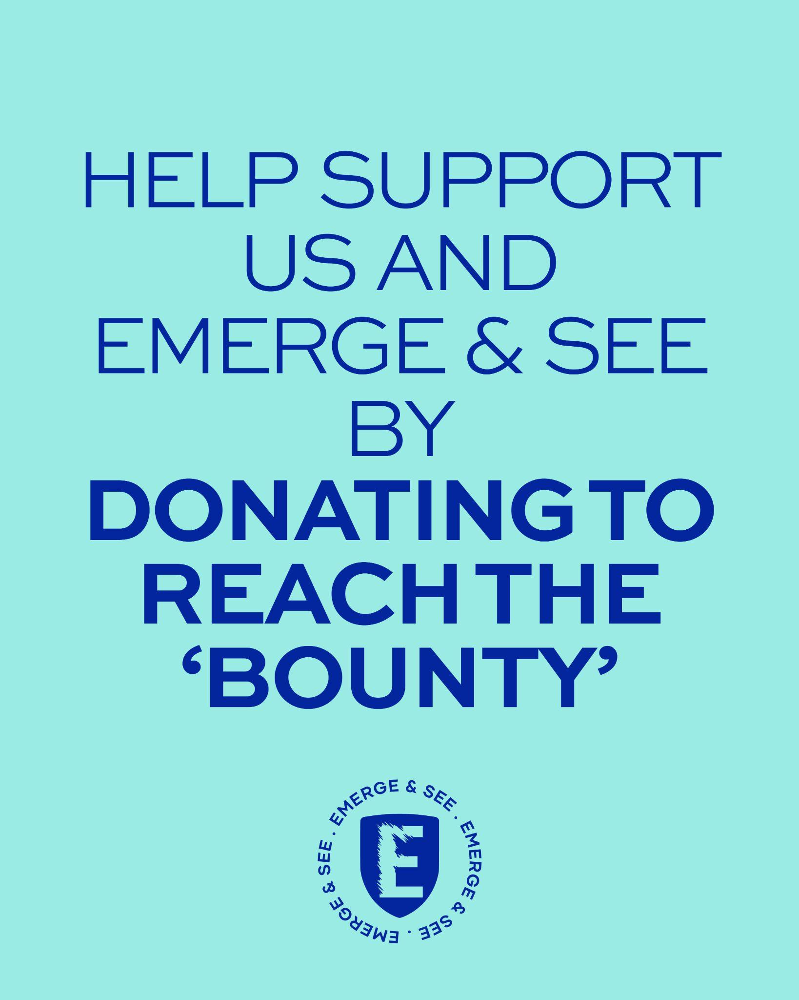
Encourage your team/community to help hit your ‘bounty’ (fundraising target) by donating to
your fundraising page.

Suggested post wording - Or use your own words.

We have set a $***** Bounty on (TEAM LEADER - Main Targets) head. Help us reach the
bounty by DATE (before 27 June) by donating to our fundraising page (ADD LINK FOR
FACEBOOK) Link in my Bio (FOR INSTAGRAM). When we Smash the Bounty, (TEAM
LEADER - Main Targets) will smash a Pie in their face for PTSD. Let’s show our support and
SMASH THE STIGMA of Emergency Service PTSD. Let’s get Messy for Mental Health.
TAG @emergeandseenswandact #PIE4PTSD #neverjustanumber #SmashTheStigma

You can keep posting this as a reminder for people to keep donating.
Thank you for your generous donations to reach the bounty. We are getting close. Do you want to see (TEAM LEADER - Main Targets) take a PIE IN THE FACE FOR PTSD? We need to hit the target of $***.
Visit our fundraising Page (ADD LINK FOR FACEBOOK) Link in my Bio (FOR INSTAGRAM) or add link to reel or story (FOR INSTAGRAM).
Let's SMASH THE STIGMA of PTSD.
TAG @emergeandseenswandact #PIE4PTSD #neverjustanumber #SmashTheStigma

TILE NUMBER 3.
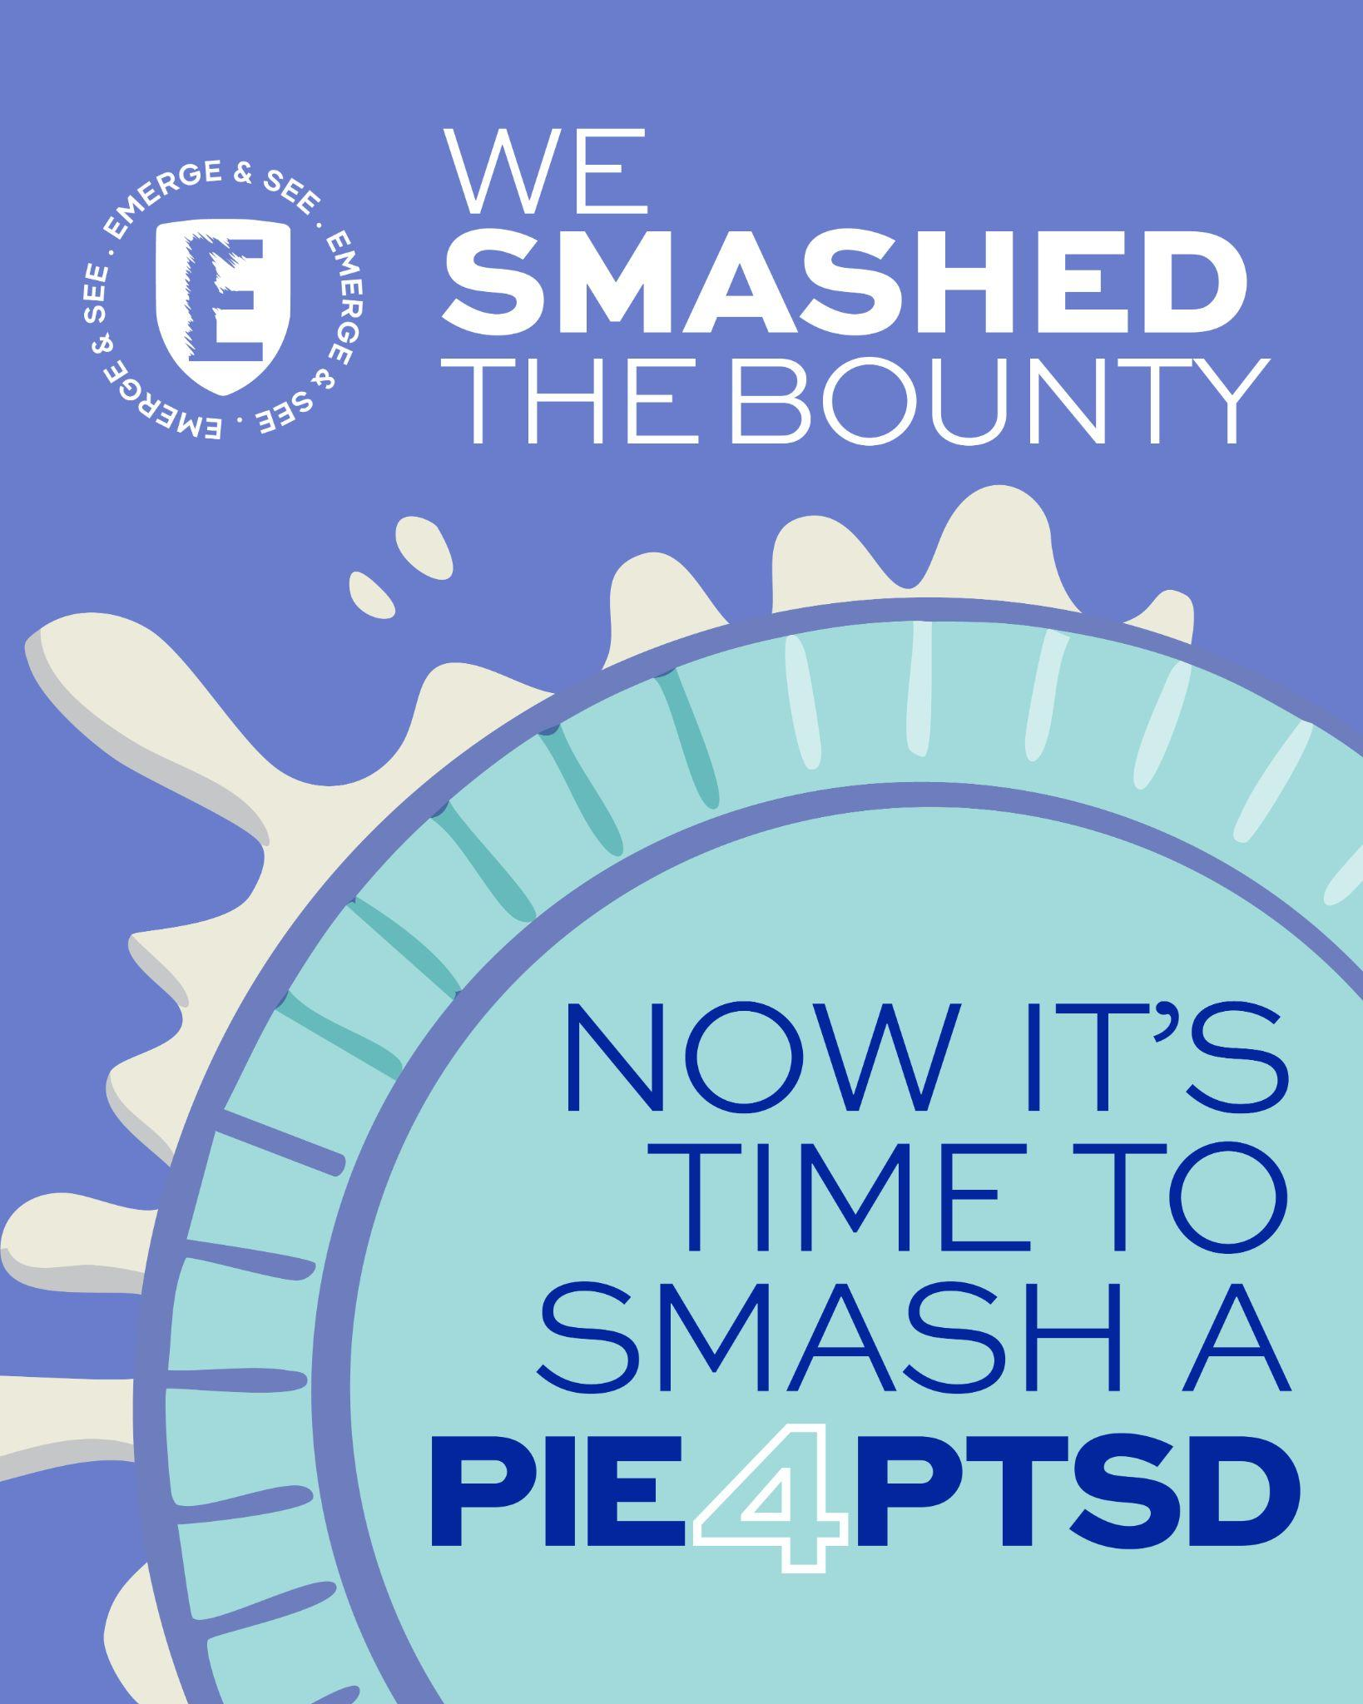
Let your family/friends/community know what you achieved together.

Suggested post wording - Or use your own words.
WE DID IT! We smashed the bounty, now let’s smash the stigma. POST A VIDEO OR PHOTOS OF YOUR PIE IN THE FACE FOR PTSD. Share the mess, and the message that we can Smash the stigma of PTSD.

SUGGESTED VIDEO WORDING & PHRASES To nominate other businesses
We’ve helped smash the stigma of PTSD. Will you step up and face the challenge?
We nominate (Person or business) to face the PIE4PTSD challenge and help smash the
stigma and a pie in the face for PTSD

You could use the opportunity to nominate someone else to stand up and smash a PIE4PTSD
TAG @emergeandseenswandact #PIE4PTSD #neverjustanumber #SmashTheStigma

TILE NUMBER 4.
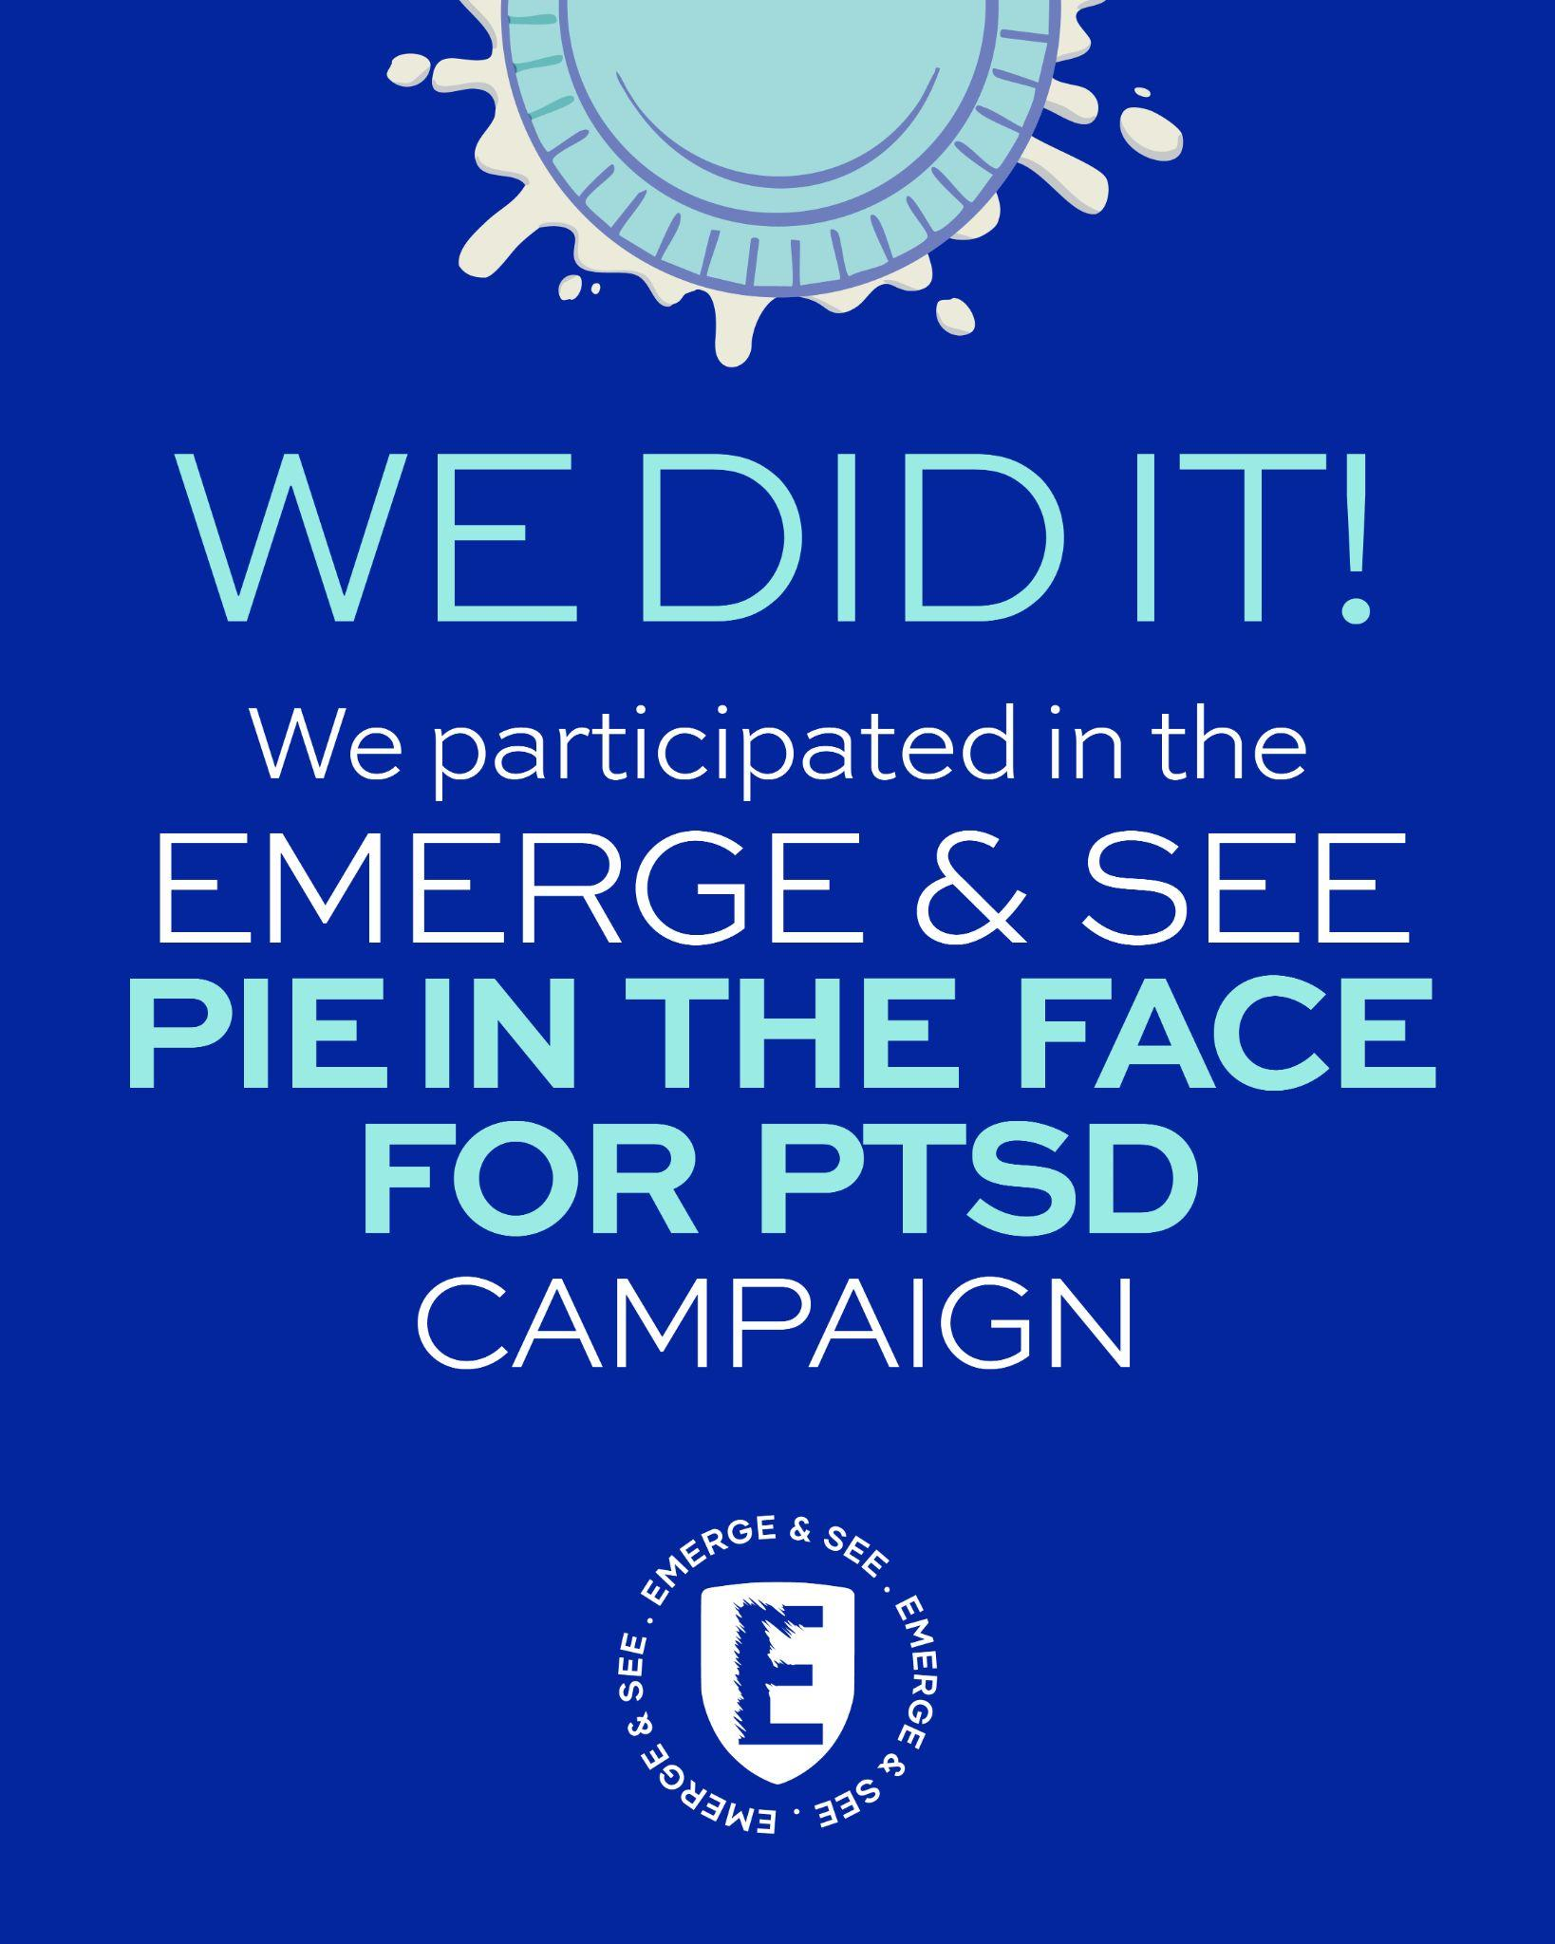
Let your community know how much you raised.

Suggested post wording - Or use your own words.
WE DID IT! We smashed the PIE4PTSD bounty and raised $**** for @emergeandseenswandact and our Emergency Service community. These funds are vital in providing FREE, INDEPENDENT and CONFIDENTIAL peer based, support, education, guidance and connection, ensuring our Emergency service community can Emerge & See a better future.

TAG @emergeandseenswandact #PIE4PTSD #neverjustanumber #SmashTheStigma #PieOfOrigin

We’ve helped smash the stigma of PTSD. Will you step up and face the challenge?
We nominate (Person or business) to face the PIE4PTSD challenge and help smash the
stigma and a pie in the face for PTSD

DON’T FORGET YOU ALSO GET A CUSTOMISED WORKPLACE/TEAM POSTER SENT OUT. If you haven’t received one, email impact@emergeandsee.org.au

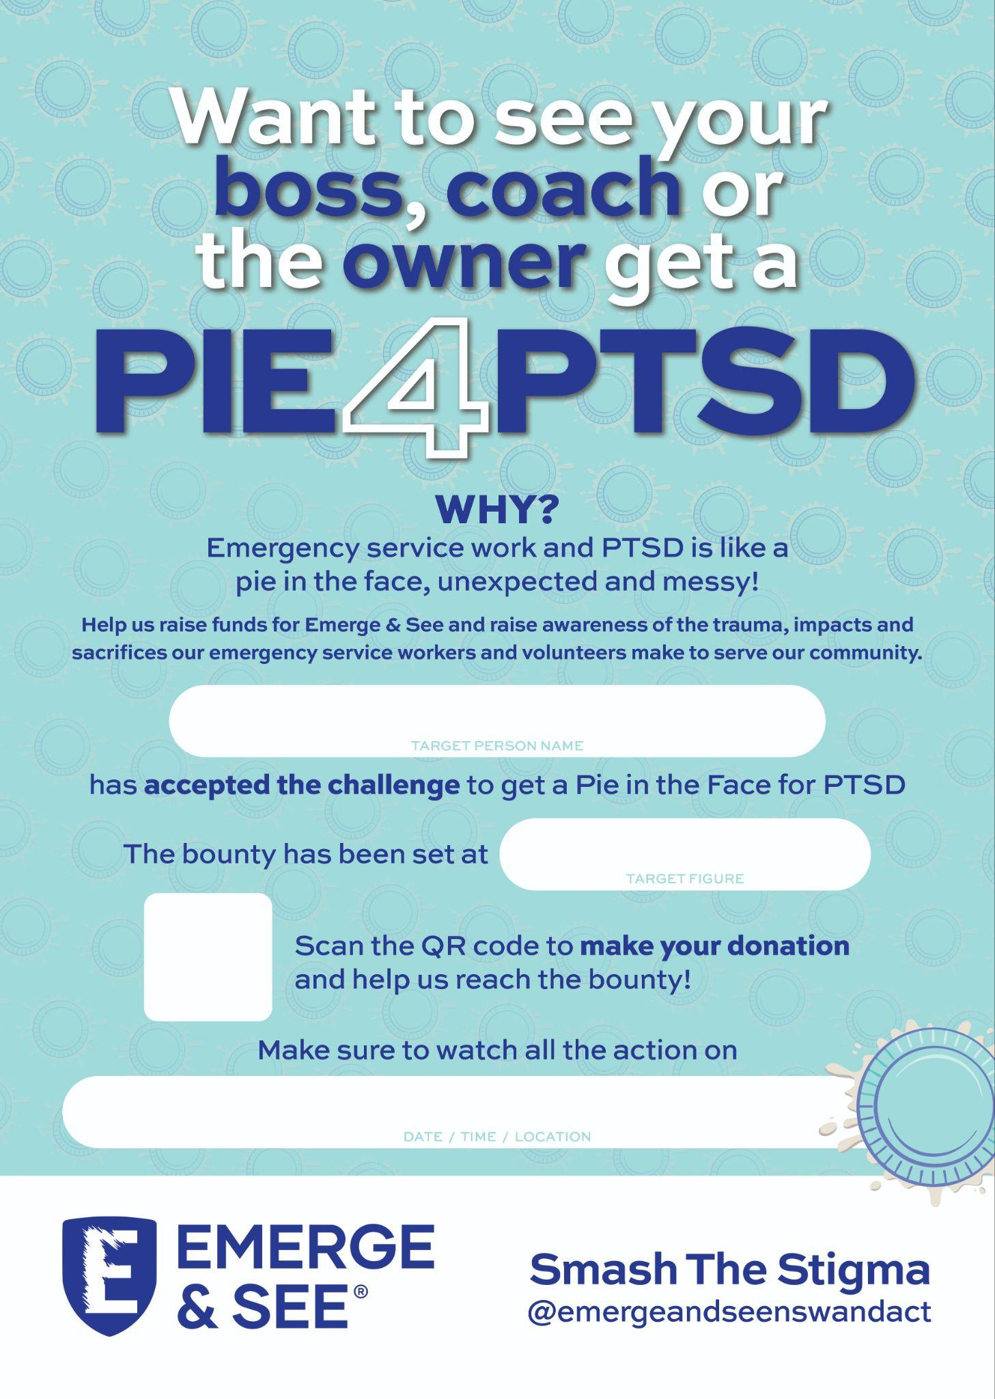

CAFE | PIE SHOP | PATISSERIE

DON’T FORGET YOU ALSO GET A POSTER SENT OUT TO LET CUSTOMERS KNOW YOU ARE PARTICIPATING. If you haven’t received one, email impact@emergeandsee.org.au


