Social Media Tiles

‘INSTRUCTION SHEET’ for Individuals
Social Media tiles attached to be downloaded

Add your fundraising page link to your Instagram bio or use the links in your stories and reels.
On Facebook and LinkedIn, links will work in the description of each post.
TAG @emergeandseenswandact
#PIE4PTSD #neverjustanumber #SmashTheStigma #PieOfOrigin

How to Add a Link to Your Instagram Bio
- Open the Instagram app on your phone
- Go to your profile by tapping your profile picture in the bottom right corner
- Tap “Edit Profile” at the top of your profile
- Under “Website”, paste your fundraising link
Individual: http://emergeandsee.funraisin.com.au/YOURNAME
- Tap “Done” or the tick in the top right corner to save

CONT.

TILE NUMBER 1
Let your family, friends and network know you are standing up and smashing the stigma of PTSD by participating in PIE4PTSD.
Suggested post wording – or use your own words
Between 27 May and 27 June, I’m standing up and taking the PIE IN THE FACE FOR PTSD challenge because our Emergency Service Community are 3 TIMES MORE LIKELY to suffer psychological distress, and every 4 weeks in Australia a Police Officer, Paramedic or Firefighter will take their own life.

Suggested Video Script
Standard Script:
"I’m participating in the PIE4PTSD Challenge, smashing the stigma of Emergency Service PTSD, one pie at a time.
I’ve got a $XXXX bounty on my head. To watch me take a pie to the face, you can donate to my fundraising page [choose one: link in this reel / link in my bio / link in this post].
When we hit the bounty, you’ll get to see me take a pie to the face!"

Optional Add-ons
Why this matters to you:
"This campaign is important to me because…"
Key Statistics (optional):
"Every 4 weeks in Australia, one Police Officer, Firefighter or Paramedic will take their own life.
Emergency service workers are 3 times more likely to experience PTSD than the general population, and that doubles to six times after 10 years of service."

Prefer Not to Be on Camera?


No problem — you can:
- Share the official PIE4PTSD social media tiles - download these at (insert website address)
- Write a short caption encouraging support and any other information (stats, or why you are involved)
- Add your fundraising link [choose one: link in reel / link in my bio (posts) / link in this post].
I’ve set a bounty of $**** to help smash the stigma of Emergency Service PTSD and earn a pie in the face. Use the link to donate and help me reach my target. Once the bounty is reached… let the pie smashing begin.

Optional additions:
Let’s SMASH THE STIGMA
I’m participating in the PIE4PTSD challenge
I’m getting messy for mental health
Emergency service mental health matters to me because…
THIS CAN BE A WRITTEN POST WITH THE SOCIAL MEDIA TILE OR A VIDEO MESSAGE (OR BOTH)
FACEBOOK: add your fundraising link
INSTAGRAM: link in bio / link in reel or story

TILE NUMBER 2

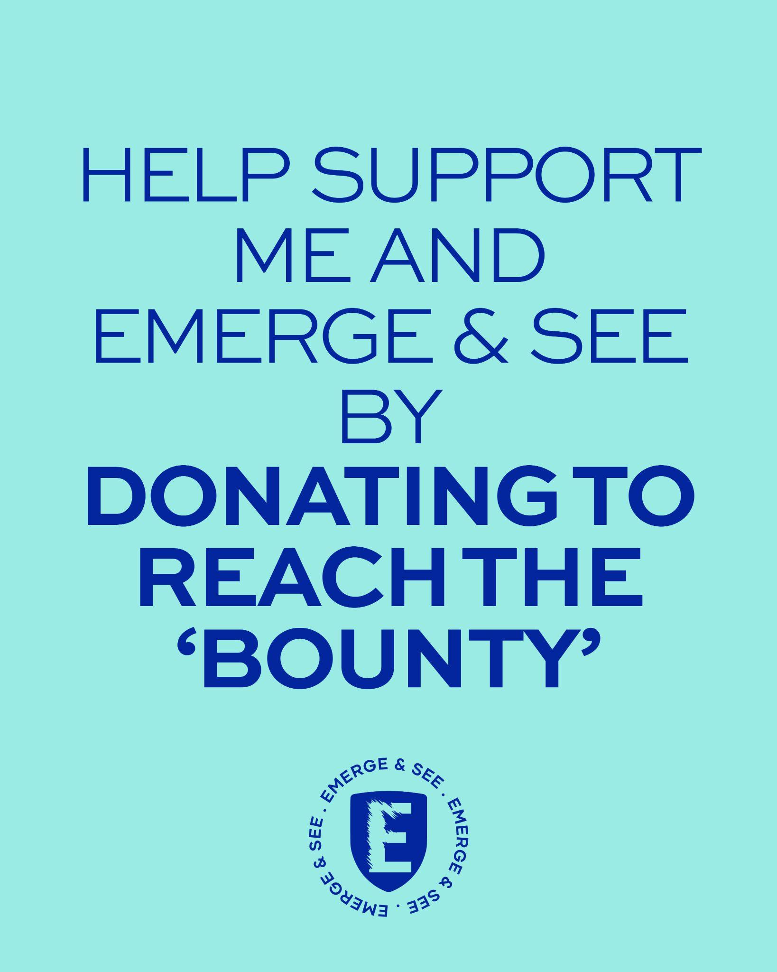
Encourage your network to help you hit your ‘bounty’ (fundraising target).
Suggested post wording – or use your own words

I’ve set a $**** bounty on my head. Help me reach my target by (DATE – before 27 June) by donating to my fundraising page.
(ADD LINK FOR FACEBOOK)
Link in my bio (FOR INSTAGRAM)
When I smash the bounty, I’ll be taking a pie in the face for PTSD.
Let’s show our support and SMASH THE STIGMA of Emergency Service PTSD.
Let’s get messy for mental health.
TAG @emergeandseenswandact #PIE4PTSD #neverjustanumber #SmashTheStigma

Reminder post option:
Thank you for your generous donations — I’m getting close!
Do you want to see me take a PIE IN THE FACE FOR PTSD?
I need to hit my target of $***.
Donate here: (ADD LINK FOR FACEBOOK)
Link in my bio (FOR INSTAGRAM)
Let’s SMASH THE STIGMA
TAG @emergeandseenswandact #PIE4PTSD #neverjustanumber #SmashTheStigma

TILE NUMBER 3
Let your network know what you achieved.
DON’T WANT TO SHOW THE MESS
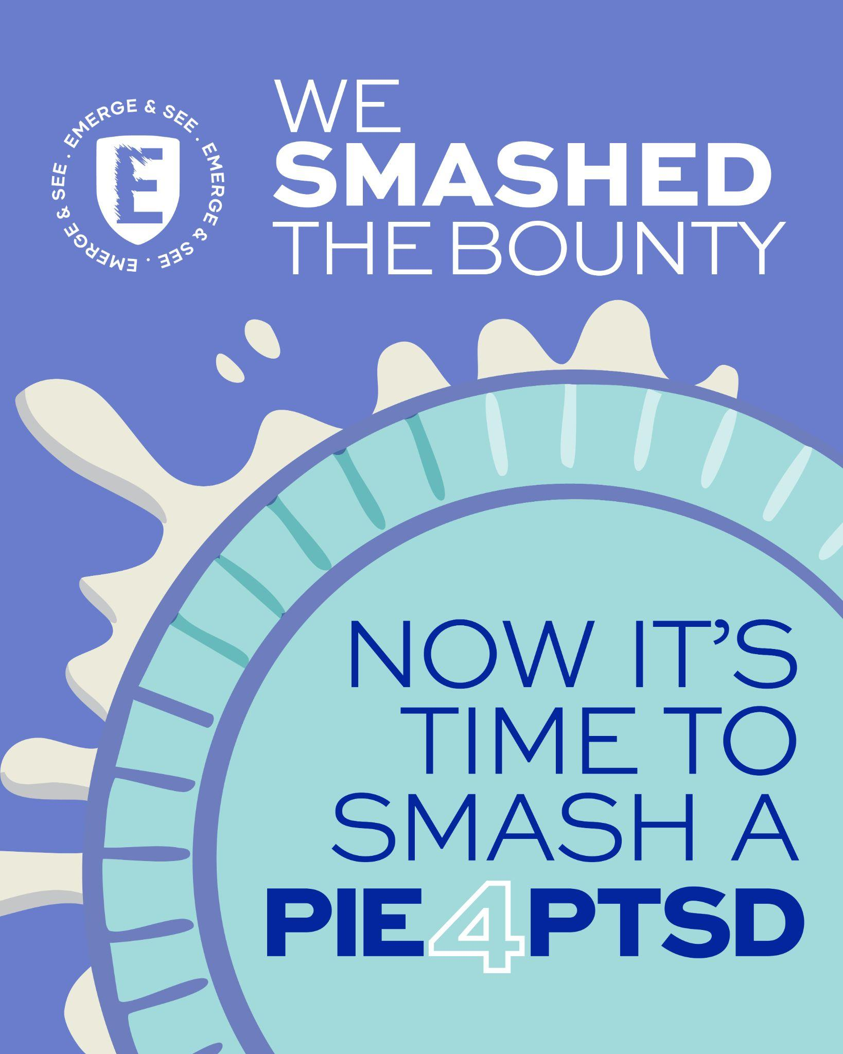
Suggested post wording – or use your own words
WE DID IT! I smashed the bounty — now let’s smash the stigma.
(POST VIDEO OR PHOTOS OF YOUR PIE IN THE FACE)
Sharing the mess and the message — together we can smash the stigma of PTSD.

Suggested “Pie Moment” Script PRIOR TO THE PIE:
"Thank you all for your generous donations and support in the PIE4PTSD Challenge.
I hit my bounty and raised $XXXX so now, you get to see me take a pie to the face!"

Optional AFTER THE PIE:
- Nominate a friend, family member, or colleague to take the challenge next

TAG @emergeandseenswandact #PIE4PTSD #neverjustanumber #SmashTheStigma #PieOfOrigin

TILE NUMBER 4

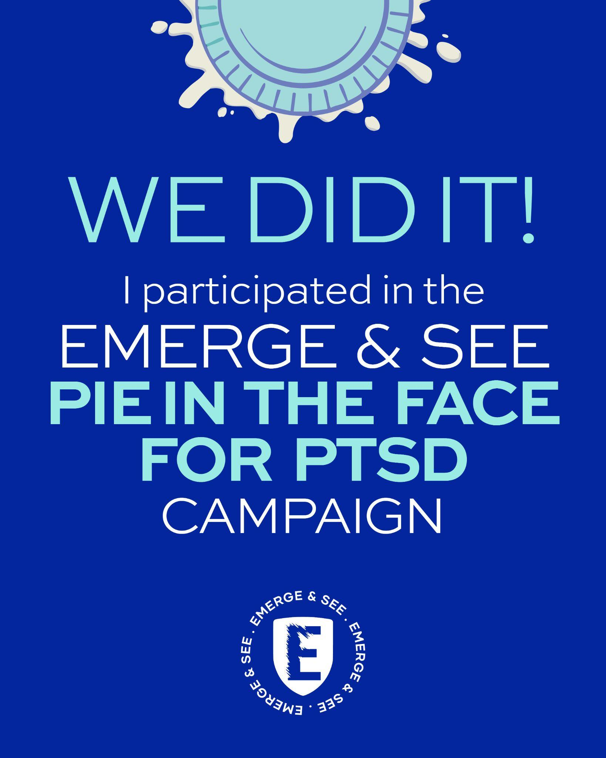
Let your network know how much you raised.
Suggested post wording – or use your own words

WE DID IT! I smashed my bounty and raised $**** for @emergeandseenswandact and our Emergency Service community in the PIE4PTSD challenge.
These funds help provide FREE, INDEPENDENT and CONFIDENTIAL peer-based support, education, guidance and connection, helping our Emergency Service community Emerge & See a better future.
TAG @emergeandseenswandact
#PIE4PTSD #neverjustanumber #SmashTheStigma #PieOfOrigin
Optional:
I’ve helped smash the stigma of PTSD — will you step up and face the challenge?
I nominate (PERSON) to take on the PIE4PTSD challenge.

BACK THE PIE OF ORIGIN ON SOCIALS AND ENCOURAGE PEOPLE TO BACK

NSW | MARK GEYER | THE BLUES. USE THIS SOCIAL MEDIA TILE
Suggested caption.
DONATE TO VOTE. I DID! Let’s watch THE BLUES WHITE WASH THIS PIE OF ORIGIN
with this link to donate
https://fundraise.emergeandsee.org.au/event/pie4ptsd-2026/pie-of-origin-nsw

BACK THE PIE OF ORIGIN ON SOCIALS AND ENCOURAGE PEOPLE TO BACK

QLD | WALLY LEWIS | THE MAROONS. USE THIS SOCIAL MEDIA TILE
Suggested caption.
DONATE TO VOTE. I DID! Let’s watch THE KING FINALLY GIVE IT TO MG THIS PIE OF ORIGIN
with this link to donate
https://fundraise.emergeandsee.org.au/event/pie4ptsd-2026/pie-of-origin-qld

